
Dedan Kimathi University of Technology
School of Computer Science and Information Technology.
Information Technology Department

ProQuire: An AI-Assisted Web-Based Platform for Connecting Clients with Skilled Technicians and Service Agencies

C025-01-0610/2023
MURIITHI HARRISON NJOROGE

The final project proposal submitted in partial requirement for the degree in Bachelor of Science in Information Technology

[September, 2026 ]

DECLARATION
Student's Declaration.
I, Harrison Njoroge, hereby declare that this project proposal titled ProQuire: An AI-Assisted Web-Based Platform for Connecting Clients with Skilled Technicians and Service Agencies is my original work. It has not been submitted for any other degree, diploma, or certificate at this or any other university. All sources of information used in this proposal have been duly acknowledged.

Signature: ___________________________
Date: _______________________________

Supervisor's, Declaration.
This project proposal has been submitted for examination with my approval as the University Supervisor.
Name: Hellen Mwangi.

Signature: ___________________________
Date: _______________________________

ABSTRACT
Accessing reliable technical service providers remains a significant challenge for many individuals and organizations despite the increasing adoption of digital technologies. Clients often rely on word-of-mouth referrals, social media platforms, or informal communication channels to locate skilled technicians, making it difficult to assess service quality, verify qualifications, and compare available options. Independent technicians and service agencies also face challenges in marketing their services, managing job requests, establishing credibility, and accessing sustainable digital platforms for service management.
This proposal will present the design and development of ProQuire, an AI-assisted web-based platform that will connect clients with skilled technicians and registered service agencies through a centralized digital platform. The primary objective will be to simplify service discovery, improve service provider visibility, strengthen trust through AI-assisted document verification, and provide subscription-based services for technicians and agencies. The platform will also provide reporting and analytics capabilities to support monitoring and informed administrative decision-making.
The project will adopt the Agile Software Development Methodology to facilitate iterative development, continuous user feedback, and incremental system improvement. The system will be developed using React.js for the frontend, Node.js with Express.js for the backend, MySQL for database management, and JSON Web Tokens (JWT) for secure authentication. Optical Character Recognition (OCR) and document authenticity analysis techniques will be integrated to assist administrators in reviewing certificates and other supporting documents submitted by technicians and agencies. A subscription payment module will be implemented to manage paid service plans, while reports and analytics will provide insights into users, service requests, subscriptions, and verification activities. The expected outcome will be a secure, responsive, and user-friendly platform that will improve service accessibility, enhance trust, support service provider operations, and improve administrative decision-making within the technical services sector.
Keywords: Technical Service Marketplace, Artificial Intelligence, Document Verification, Optical Character Recognition (OCR), Subscription Payment, Reports and Analytics, Web Application, React.js, Node.js, MySQL, Agile Methodology.
.

CHAPTER ONE: INTRODUCTION
  - Background information.
The rapid advancement of ICT has transformed how individuals and organizations access and manage services. Internet connectivity, smartphones, and web applications have made it easier to connect service providers with clients and improve service delivery through centralized digital platforms.
Despite these advancements, accessing reliable technical services remains a challenge in Kenya. Clients seeking electricians, plumbers, mechanics, carpenters, and other technicians often rely on referrals, social media, or advertisements, which provide limited information about qualifications, experience, availability, and previous work. Technicians also face difficulties reaching wider markets, while service agencies may struggle to manage technicians, service requests, job assignments, and service records efficiently.
Trust and verification are further challenges. Manually checking identification documents, professional certificates, and business documents can be time-consuming and may not easily reveal forged or inconsistent information. The use of Artificial Intelligence (AI), Optical Character Recognition (OCR), and document analysis can assist administrators in reviewing submitted documents and identifying potential inconsistencies while retaining human oversight for final verification.
There is also a need for sustainable digital services through subscription and payment functionality, as well as reports and analytics to support administrative monitoring and decision-making. Therefore, this project proposes ProQuire, an AI-assisted web-based technical service marketplace that will connect clients with skilled technicians and registered service agencies. The platform will integrate service discovery, provider profiles, service requests, agency and technician management, AI-assisted document verification, subscription and payment services, and administrative reports and analytics to improve accessibility, trust, efficiency, and reliability in technical service delivery.

  - Problem Statement.
The demand for technical services is increasing, yet finding qualified and trustworthy technicians remains largely informal. Clients often rely on referrals, social media, or advertisements that provide limited information about providers, increasing the risk of poor workmanship, delays, and financial losses. Technicians also struggle to reach wider markets and establish professional credibility, while service agencies may rely on fragmented methods to manage technicians, service requests, job assignments, and service records.
Another challenge is provider verification. Manually reviewing identification documents, professional certificates, and business documents is time-consuming and may not easily reveal altered or inconsistent information. Existing service platforms also provide limited integration of AI-assisted verification, agency management, and technician management within a single system.
Furthermore, technicians and agencies need sustainable digital services, including subscription and payment functionality, while administrators require reports and analytics to monitor users, service requests, subscriptions, verification activities, and overall system usage. Existing platforms largely focus on service discovery and individual providers, with limited integration of these features.
Therefore, there is a need for a secure, centralized, and intelligent technical service platform that integrates service discovery, technician and agency management, AI-assisted document verification, service requests, subscription and payment management, and reports and analytics. This project proposes ProQuire to address these challenges and improve trust, efficiency, accessibility, and reliability in technical service delivery.

  - Objectives

    - Main Objective

The main objective of this project is to design and implement ProQuire, an AI-assisted web-based platform that enables clients to efficiently discover, evaluate, and hire skilled technicians or registered service agencies while enhancing transparency, trust, and service delivery through intelligent document verification and centralized service management.

    - Specific Objectives
i. To develop a web-based platform that enables clients to search for, compare, and request services from verified technicians and registered service agencies based on service category, specialization, location, ratings, and reviews.
ii. To implement secure user management through authentication, authorization, technician and agency profile management, an AI-assisted document verification module using Optical Character Recognition (OCR) and document authenticity analysis, and an administrative dashboard for user verification and platform administration.
iii. To develop a secure subscription payment module that enables technicians and service agencies to subscribe to premium services and manage their subscription status.
iv. To develop a reporting and analytics module that provides administrators with insights into user registrations, subscriptions, service requests, verification activities, and overall system usage.
v. To evaluate the developed system by conducting functional, usability, performance, and security testing, and by verifying that each functional requirement is implemented and operates as intended.

  - Scope
This project will focus on the design and development of ProQuire, an AI-assisted web-based technical service marketplace. Clients will be able to search for technicians and registered service agencies, view their profiles, submit service requests, monitor requests, and provide ratings and reviews.
Technicians and agencies will be able to manage profiles, showcase portfolios, and handle service requests, while agencies will additionally manage technicians and assign jobs. Administrators will manage users, service activities, verification, and platform operations.
The system will include an AI-assisted document verification module using OCR and document authenticity analysis to support the review of identification documents, certificates, and business documents. Final verification decisions will remain with the administrator.
ProQuire will also provide subscription and payment functionality for technicians and agencies, together with reports and analytics to help administrators monitor users, service requests, subscriptions, verification activities, and overall system usage.

  - Significance /justification
The proposed ProQuire platform will improve the delivery and management of technical services by providing a centralized, secure, and efficient digital platform for clients, technicians, service agencies, and administrators.
For clients, the platform will simplify the process of finding qualified technicians and registered service agencies through profiles, service categories, ratings, reviews, and verified credentials. This will support informed decision-making, reduce the risk of engaging unqualified providers, and improve customer satisfaction. For technicians, ProQuire will provide opportunities to market their skills, showcase completed projects, reach a wider customer base, and improve professional visibility.
For service agencies, the platform will support organization registration, technician management, service requests, job assignment, and service record management. This will improve operational efficiency, communication, and coordination. The AI-assisted document verification module will further enhance trust and transparency by assisting administrators in reviewing identification documents and certificates before approving technicians and agencies, while maintaining human oversight.
Finally, ProQuire will contribute to the adoption of Artificial Intelligence in web-based service platforms by demonstrating how AI-assisted verification can be integrated into an online technical service marketplace. The project may also provide a foundation for future development and research in intelligent service management systems and serve as a reference for developers and researchers interested in similar applications.
CHAPTER TWO: LITERATURE REVIEW

  - Chapter Introduction

This chapter reviews previous studies and existing systems related to the provision of technical services through digital platforms. It discusses similar and related project case studies that connect clients with skilled technicians and service providers while examining the technologies and approaches used to improve service delivery. The chapter highlights the strengths and weaknesses of each case study, with particular attention to technician verification, agency management, and user trust. It also reviews relevant concepts such as Artificial Intelligence (AI)-assisted document verification and web-based service management systems. Finally, the chapter identifies the research gaps that the proposed ProQuire platform seeks to address and demonstrates how the proposed solution improves upon existing systems.

  - Case studies
    - FundiLink
FundiLink is a Kenyan web-based platform that connects clients with skilled professionals across various service categories, including plumbing, electrical installation, carpentry, painting, cleaning, and construction services. The platform enables technicians to create professional profiles where they can showcase their skills, experience, completed projects, and customer reviews. Clients can search for service providers, compare profiles, request quotations, and communicate directly with technicians through the platform.
One of FundiLink's key strengths is its user-friendly interface and wide range of supported service categories, making it easier for customers to identify suitable professionals. The platform also promotes transparency through technician profiles, ratings, reviews, and portfolio displays, enabling clients to make more informed hiring decisions.
Despite these strengths, FundiLink primarily focuses on connecting individual technicians with clients. It provides limited support for service agencies that manage multiple technicians and does not prominently incorporate AI-assisted verification of uploaded professional documents. Verification largely depends on conventional administrative processes, which may increase the time required to approve users and may not effectively detect altered or fraudulent documents.
The analysis of FundiLink demonstrates the effectiveness of digital marketplaces in improving access to technical services while highlighting the need for enhanced verification mechanisms and support for agency-based service management. These identified limitations provide important considerations for the design of the proposed ProQuire platform.

    - MyFundi
MyFundi is a Kenyan online platform that enables clients to access a variety of professional home and business services through a centralized digital marketplace. The platform allows customers to search for technicians, request services, and review service providers based on customer feedback. It focuses on improving convenience by providing a simple process for connecting clients with qualified professionals.
The platform's strengths include an organized service booking process, technician ratings, customer reviews, and a straightforward user experience. These features contribute to improved customer confidence and simplify the process of locating service providers within different technical fields.
However, MyFundi places greater emphasis on service booking than on intelligent verification of technician qualifications and agency credentials. The platform also provides limited functionality for agencies that manage multiple technicians under one organization. Furthermore, there is little evidence of AI-assisted document verification to support administrator decisions during technician registration.
The review of MyFundi illustrates the importance of centralized service platforms while revealing opportunities for improved document verification, agency management, and intelligent trust-building features that will be incorporated into ProQuire.

    - FundiMoja
FundiMoja is a digital platform that connects clients with skilled technicians and artisans by providing an online environment where service providers can advertise their skills and customers can request technical services. The platform aims to increase the visibility of technicians while making it easier for clients to identify professionals within different service categories.
A major strength of FundiMoja is its support for multiple technical disciplines and its ability to improve technician visibility through online profiles. The platform contributes to reducing dependence on informal referrals by providing clients with a centralized location for discovering service providers.
Despite these advantages, the platform offers limited support for managing registered service agencies and does not prominently feature intelligent verification mechanisms for validating uploaded professional documents. The verification process appears to rely mainly on manual administrative procedures, which may reduce efficiency and increase the possibility of fraudulent registrations.
The findings from FundiMoja reinforce the need for a platform that combines technician management, agency support, and AI-assisted verification within a single integrated system. These considerations directly influence the design and functionality of the proposed ProQuire platform.

    - TaskRabbit
TaskRabbit is an international online marketplace that connects individuals with independent service providers for a wide range of tasks, including furniture assembly, home repairs, moving services, cleaning, electrical work, and handyman services. The platform enables users to search for service providers, compare profiles, schedule appointments, and complete service requests through a structured digital workflow.
One of TaskRabbit's major strengths is its mature service management system, which incorporates user ratings, reviews, secure booking processes, and efficient task scheduling. The platform provides an intuitive user experience and demonstrates how digital technologies can improve service accessibility and customer satisfaction on a large scale.
However, TaskRabbit primarily focuses on individual service providers and is designed for international markets with operational models that differ from local technical service industries such as those in Kenya. It also provides limited emphasis on supporting registered service agencies and does not publicly highlight AI-assisted verification of professional documents as part of its technician onboarding process.
The study of TaskRabbit provides valuable insights into best practices in online service marketplaces while demonstrating the need for a localized solution that addresses the operational requirements of Kenyan technicians, service agencies, and clients. ProQuire seeks to build upon these strengths while incorporating AI-assisted document verification and agency management features tailored to the local context.

  - The Gap
The reviewed case studies demonstrate that existing digital service platforms have significantly improved access to skilled technicians by enabling clients to search for service providers, view profiles, and access ratings and reviews. These systems have contributed to increased service visibility and more convenient service delivery.
However, several gaps remain. Most existing platforms primarily focus on connecting clients with individual technicians and provide limited support for registered service agencies that manage multiple technicians. In addition, many rely on conventional administrative procedures to verify uploaded certificates and identification documents, making it difficult to detect forged or altered credentials efficiently. This may reduce user trust and increase the risk of fraudulent registrations.
Furthermore, while existing platforms offer basic service discovery and communication features, few integrate intelligent technologies that enhance the verification process and strengthen confidence in the authenticity of service providers. There is also limited integration of technician management, agency management, document verification, service requests, portfolios, and customer feedback within a single platform.
This project seeks to address these gaps through the development of ProQuire. The system will incorporate AI-assisted document verification using Optical Character Recognition (OCR) and document authenticity analysis to support administrator verification decisions. By combining intelligent verification with centralized service management, ProQuire aims to improve transparency, trust, operational efficiency, and accessibility in the delivery of technical services.
CHAPTER THREE: METHODOLOGY

  - Chapter Introduction

This chapter describes the methodology and design approach that will be adopted in the development of the proposed ProQuire system. It begins by discussing the software development methodology selected for the project and the justification for its adoption. The chapter then presents the system requirements, overall system architecture, user interface design, and database design. It also outlines the project management tools, including the project schedule and estimated budget. These components provide the framework for designing and implementing a secure, scalable, and AI-assisted web-based platform for connecting clients with skilled technicians and registered service agencies.

  - Project Methodology
This project will adopt the Agile Software Development Methodology. Agile is an iterative and incremental approach to software development that emphasizes continuous planning, regular user feedback, collaboration, and frequent system improvements. Unlike traditional development approaches that complete the entire system before testing, Agile divides the project into smaller development cycles known as sprints. Each sprint produces a functional component of the system, allowing testing and evaluation to be carried out throughout the development process.
Agile has been selected because the proposed ProQuire platform consists of multiple modules, including client management, technician management, service agency management, AI-assisted document verification, service request management, portfolio management, reviews and ratings, and an administrative dashboard. Developing these modules incrementally will make it easier to test individual components, identify and correct errors early, and incorporate feedback from the project supervisor and prospective users before proceeding to subsequent phases.
The development process will begin with requirements gathering and system planning to identify the functional and non-functional requirements of the platform. This will be followed by system design, where the system architecture, database structure, and user interfaces will be developed. During the implementation phase, each module will be developed, integrated, and tested individually before being combined into the complete system. The AI-assisted document verification module will also be integrated and evaluated to ensure it supports administrators in verifying uploaded documents accurately. Finally, comprehensive system testing will be conducted to evaluate functionality, usability, security, and overall system performance before deployment.

  - Requirement Analysis
Requirement analysis is the process of identifying and documenting the system features and constraints necessary to meet the project objectives. It helps define what the proposed system should accomplish and the standards it should satisfy to meet user and organizational needs. The requirements for ProQuire are categorized into functional requirements, which describe the services the system will provide, and non-functional requirements, which define the quality attributes and operational characteristics of the system.

3.3.1 Functional Requirements
The proposed system shall:
i. Allow clients, technicians, service agencies, and administrators to register and securely log into the system.
ii. Enable technicians and service agencies to create and manage professional profiles, upload portfolios, and submit supporting verification documents.
iii. Allow clients to search for technicians and service agencies based on service category, specialization, and location.
iv. Enable clients to submit service requests, monitor request status, and provide ratings and reviews after service completion.
v. Provide administrators with tools to manage users, review AI-assisted document verification results, verify technicians and agencies, and monitor system activities.
vi. Analyze uploaded documents using an AI-assisted verification module to support administrator decisions by identifying extracted information and potential inconsistencies.
vii. The system shall allow technicians and service agencies to subscribe to premium plans and manage their subscription status.
viii. The system shall generate reports and analytics on user registrations, subscriptions, service requests, technician verification, and system usage for administrators.

3.3.2 Non-Functional Requirements
The proposed system shall:
i. Provide a user-friendly and responsive interface that is accessible from desktop and mobile web browsers.
ii. Ensure secure user authentication and password protection through encrypted credentials and role-based access control.
iii. Maintain high system availability and reliable performance during normal operation.
iv. Protect user information and uploaded documents through secure data storage and controlled access.
v. Be scalable to accommodate an increasing number of users, technicians, service agencies, and service requests without significant performance degradation.
vi. Maintain accuracy and consistency of stored information through proper database management and validation mechanisms.

  - System Architecture
System architecture describes the overall structure of the proposed system and illustrates how its major components interact to achieve the project objectives. The proposed ProQuire platform will adopt a three-tier architecture consisting of the Presentation Layer, Application Layer, and Data Layer. This architecture promotes modularity, scalability, maintainability, and secure communication between system components.
The Presentation Layer will provide the user interface through which clients, technicians, service agencies, and administrators will interact with the system using a web browser. It will be developed using React.js and will provide functionalities such as user registration, login, profile management, service search, service requests, portfolio management, document uploads, subscription management, payment interfaces, and administrative dashboards. Administrators will also be able to access reports and analytics through the interface.
The Application Layer will contain the business logic of the system and will be implemented using Node.js and Express.js. It will process user requests, manage authentication and authorization, handle service requests, technician and agency management, reviews and ratings, and facilitate communication between the user interface and the database. This layer will also contain the AI-assisted document verification module, which will analyze uploaded documents using Optical Character Recognition (OCR) and document authenticity analysis before presenting the results to the administrator for final verification. In addition, the Application Layer will include a Subscription and Payment Module responsible for managing available subscription plans, processing subscription-related requests, recording payment transactions and statuses, and updating the subscription status of technicians and agencies. A Reports and Analytics Module will also be included to process system data and provide administrators with information on user registrations, service requests, subscriptions, verification activities, and overall system usage.
The Data Layer will consist of a MySQL database responsible for securely storing user accounts, technician and agency profiles, service requests, portfolios, reviews, uploaded documents, verification records, AI verification results, subscription plans, subscription records, and payment transaction information. The database will maintain data integrity, consistency, and efficient retrieval of information required by the application. Data stored in this layer will also provide the source for generating administrative reports and analytics.
The interaction between these layers will ensure that user requests are processed efficiently while maintaining data security, system reliability, scalability, and maintainability. The AI-assisted document verification module will improve the efficiency of the verification process without replacing the administrator's final decision. The integration of subscription and payment functionality will support premium services for technicians and agencies, while the reports and analytics module will enable administrators to monitor system activities and make informed decisions based on platform data.
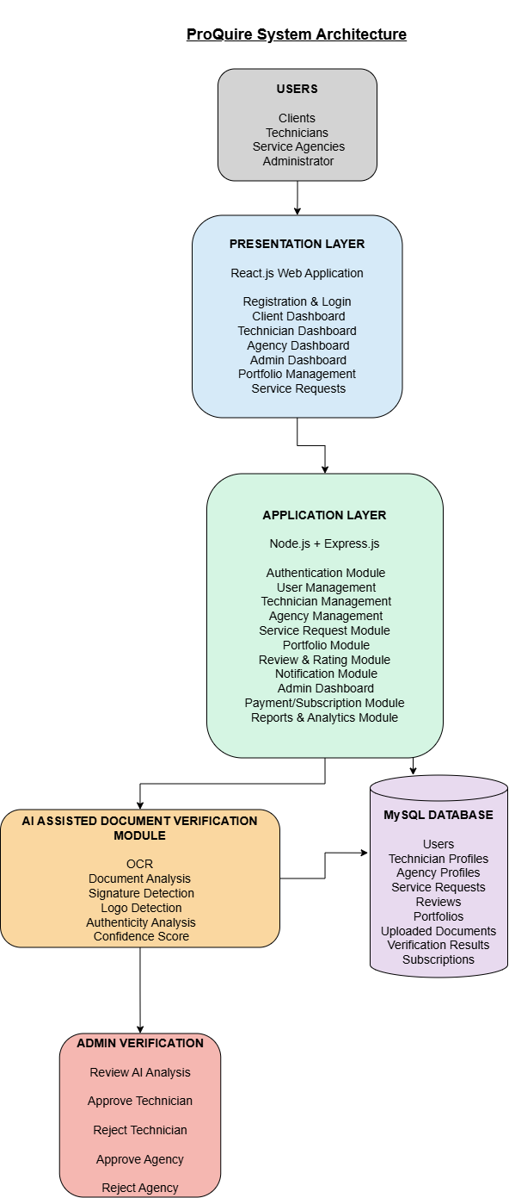Figure 3.1: System Architecture
  - User Interface Design
The proposed ProQuire system will provide a simple, responsive, and user-friendly web interface that enables users to interact with the platform efficiently. The interface will be developed using React.js and will be designed to ensure consistency, ease of navigation, and accessibility across desktop and mobile devices. Different interfaces will be provided for clients, technicians, service agencies, and administrators according to their respective roles and responsibilities.
The design will emphasize usability by providing intuitive navigation menus, clearly labeled buttons, organized dashboards, and responsive forms for user registration, service requests, document uploads, and profile management. Visual feedback such as notifications, validation messages, and confirmation prompts will guide users while interacting with the system. The administrator interface will additionally provide access to AI-assisted document verification results to support technician and agency approval decisions.
The following mock-up interfaces illustrate the proposed user interface design of the system.
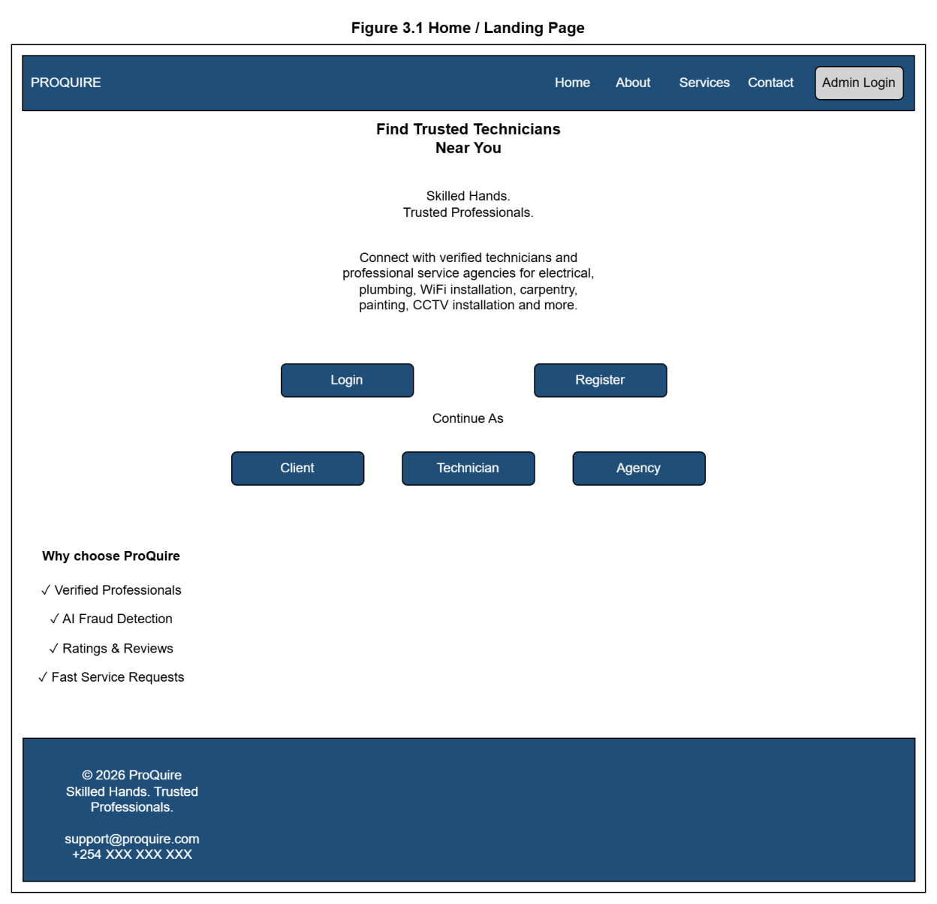
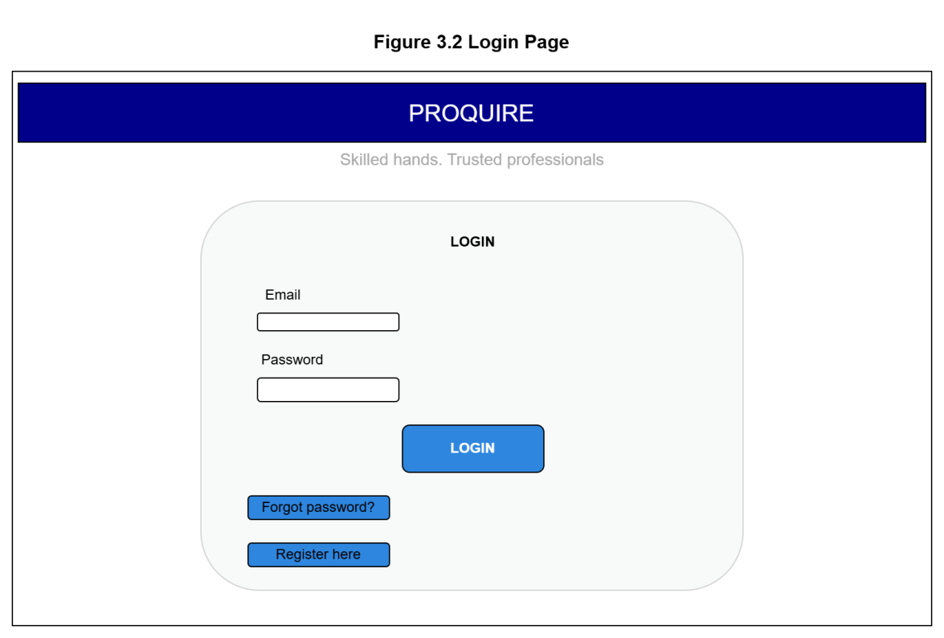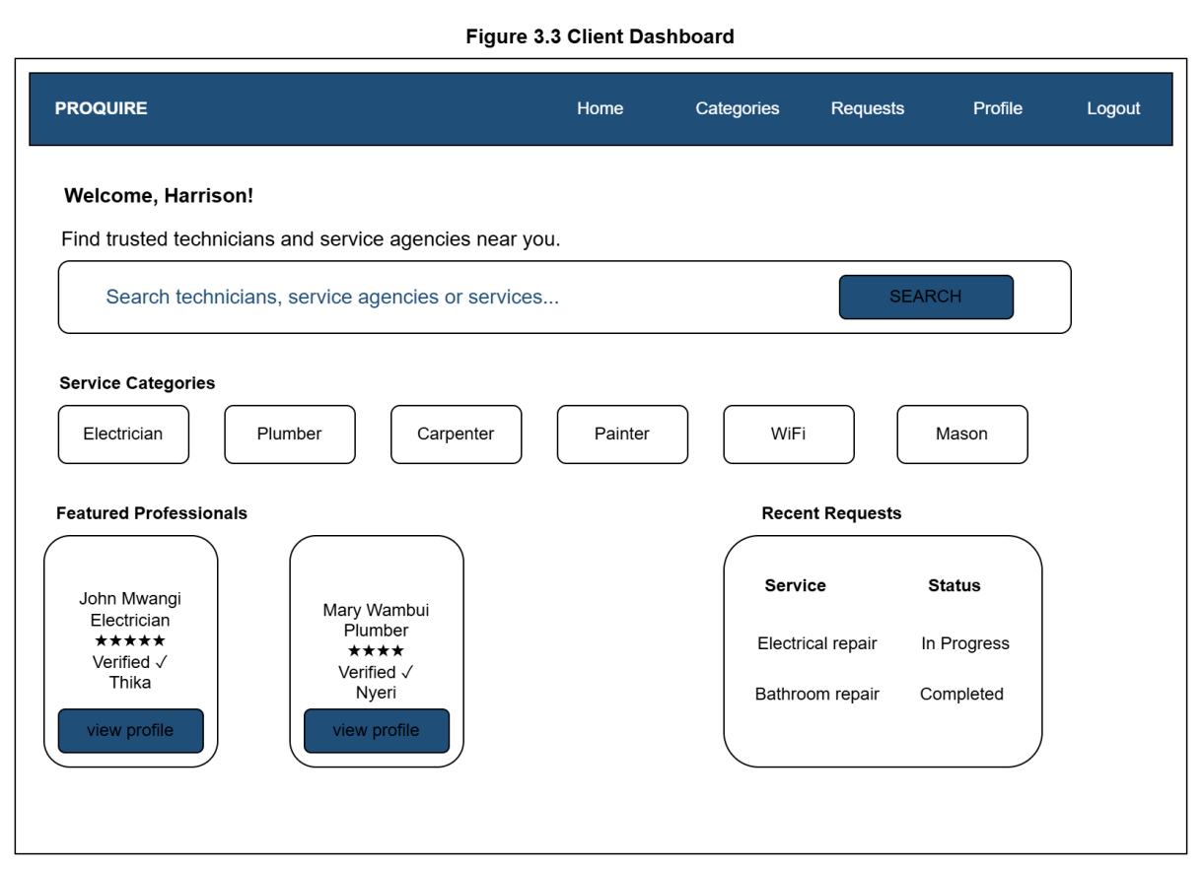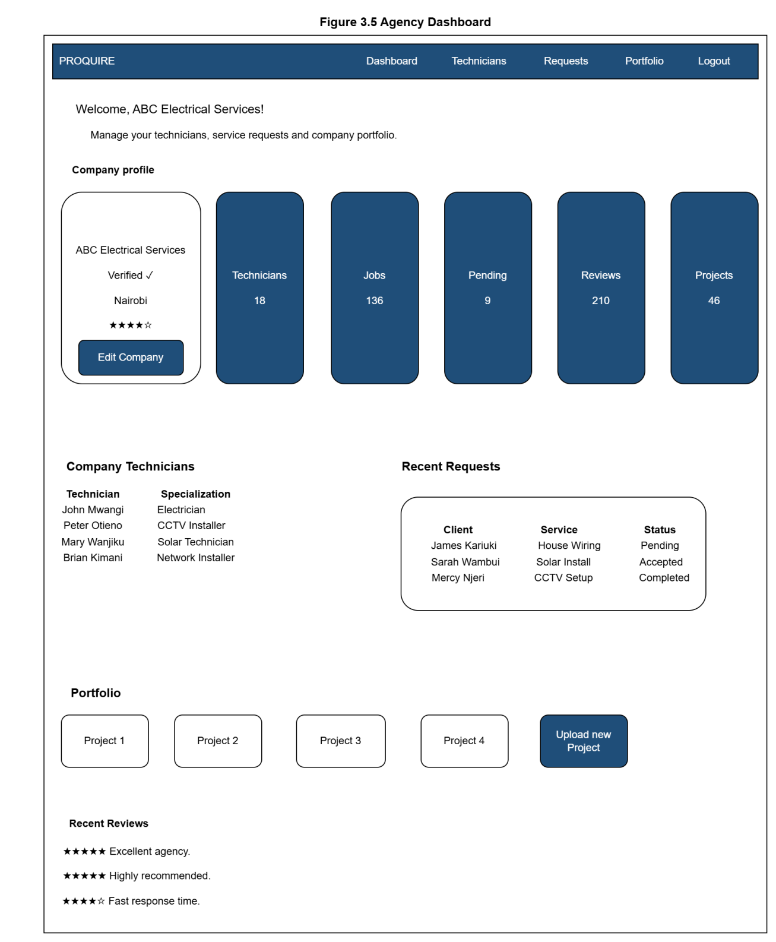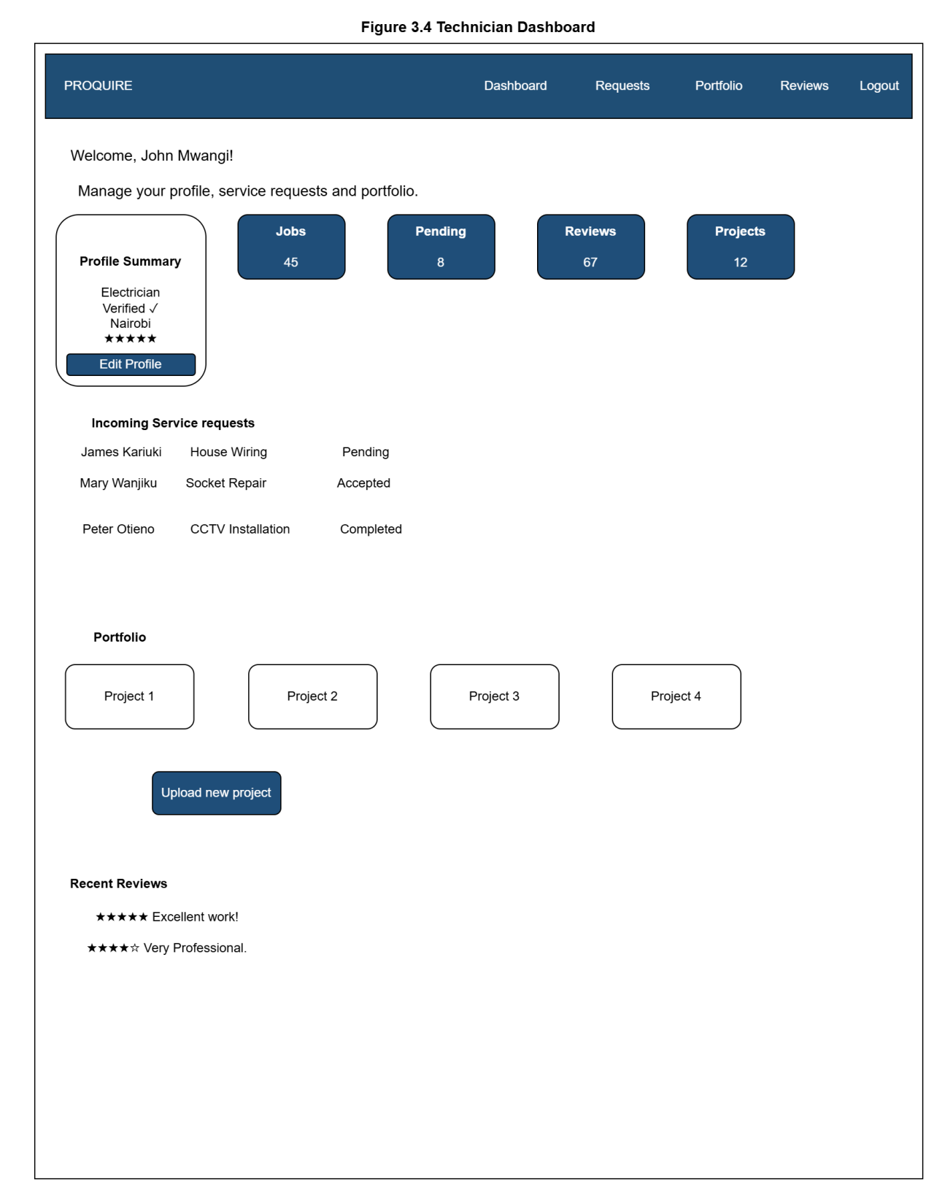
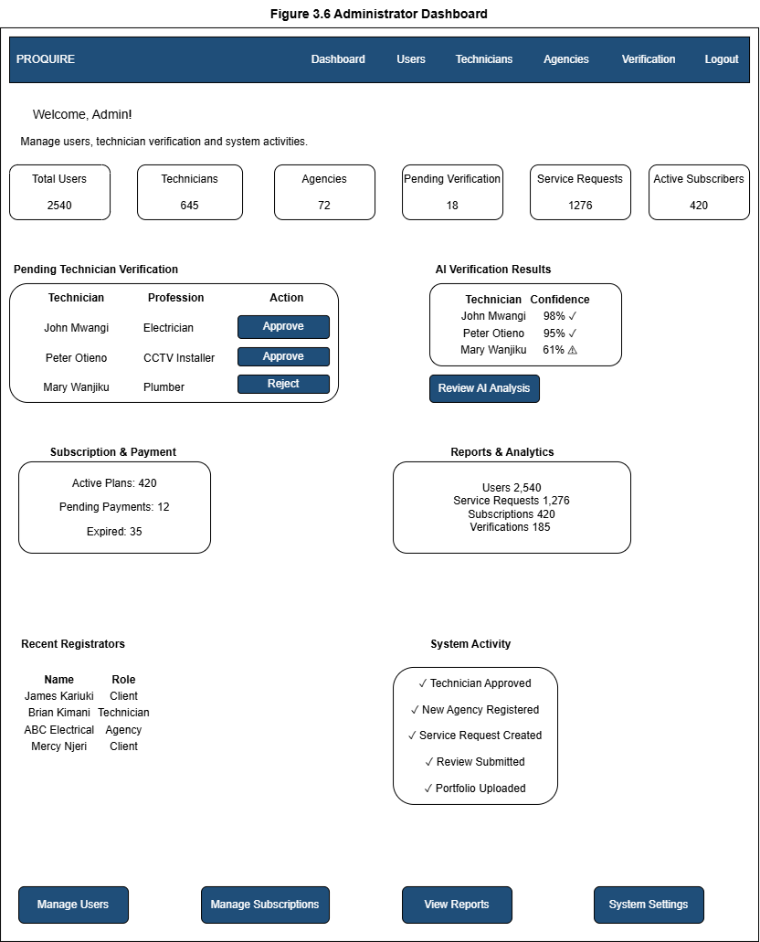
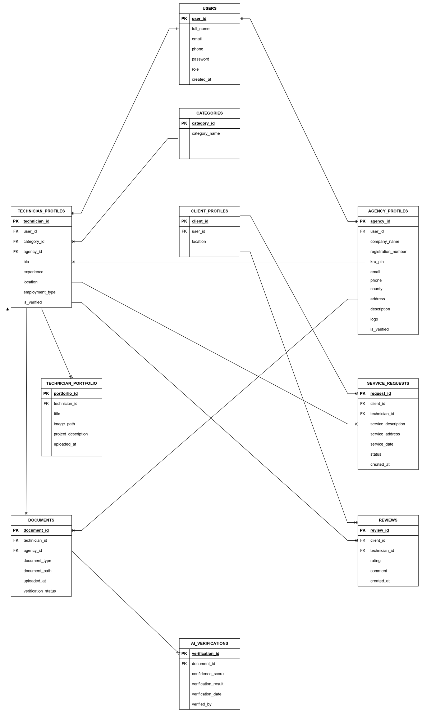

3.6 Project Management Tools
The ProQuire project will be managed using project management tools that support planning, development, collaboration, testing, and documentation.
Tool | Purpose
Git & GitHub | Version control and source code management
Visual Studio Code | Application development
Draw.io | System architecture and UI wireframes
MySQL Workbench / phpMyAdmin | Database design and management
Postman | API testing
Microsoft Word | Documentation
Google Drive | File backup and sharing

3.6.1 Project Schedule
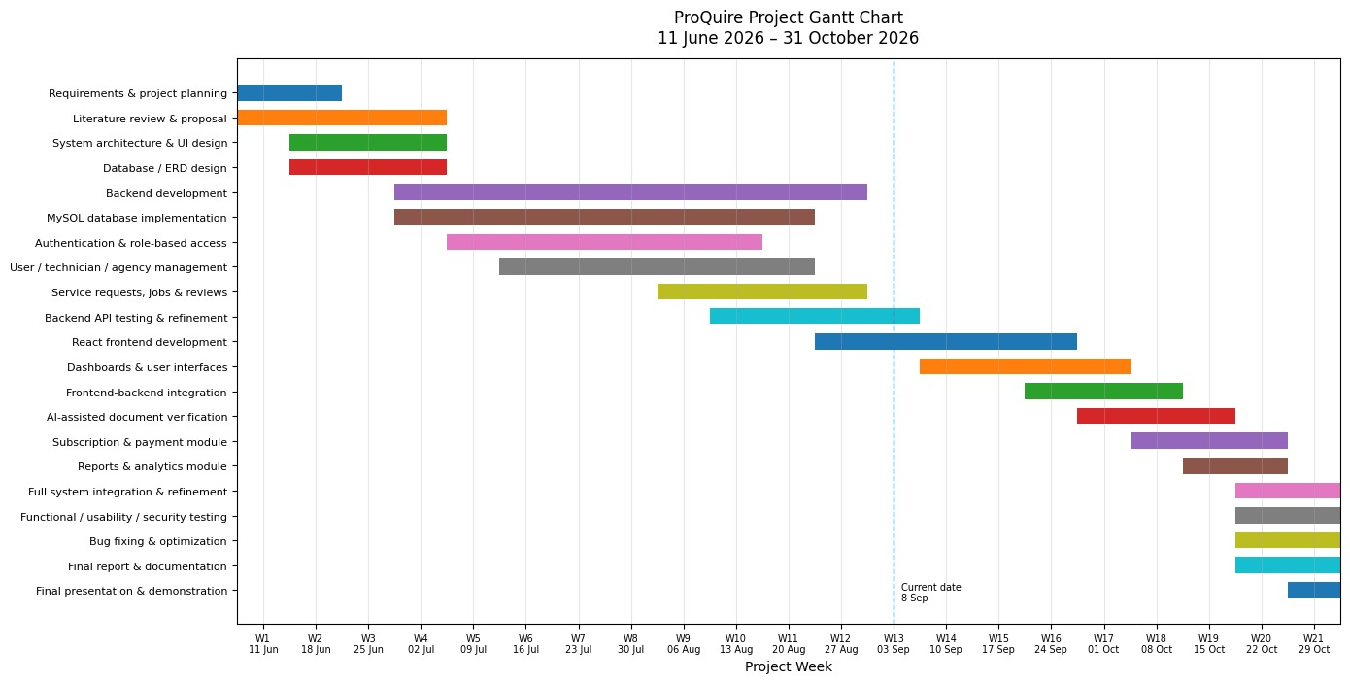

3.6.2 Expected Budget
Item | Estimated Cost (KES)
Internet | 3000
Electricity | 2000
Domain Name (optional) | 1500
Hosting (optional) | 4000
Printing & Binding | 2500
Transport for Testing | 2000
Miscellaneous | 2000
Total | 17000

References
Draw.io. https://www.diagrams.net/
FundiLink. https://fundilink.com/
FundiMoja. https://fundimoja.com/
MyFundi. https://myfundi.co.ke/
OpenAI. https://chat.openai.com/
Taskrabbit. https://www.taskrabbit.com/

